Lesson 4 Demo 5
Create a Branch in Git

Objective: To create branches in Git

Tools required: Git

Steps to be followed:
- Create a new repository
- Clone the GitHub repository
- List all the branches in your repository
- Create a new branch
- Verify the creation of the new branch
- Rename an existing branch
- Delete the branch
- Verify the deletion of the branch

Step 1: Create a new GitHub repository
1.1 Open the browser in your lab, go to github.com, and log in to your account
1.2 Click on the + icon from the upper-right corner of the page, and select New repository from the drop-down menu and then create a new repository

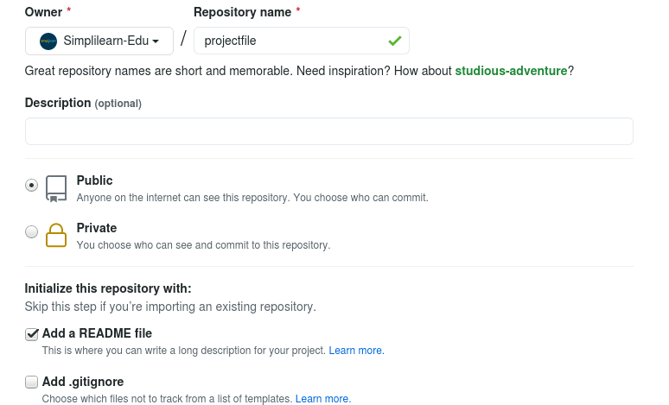

Step 2: Clone the GitHub repository
2.1 Open the browser in your lab, Go to github.com, and log in to your account
2.2 Open the projectfile repositry, and click on the Code button
2.3 Click on the icon as shown in the following screenshot to copy the URL provided under HTTPS
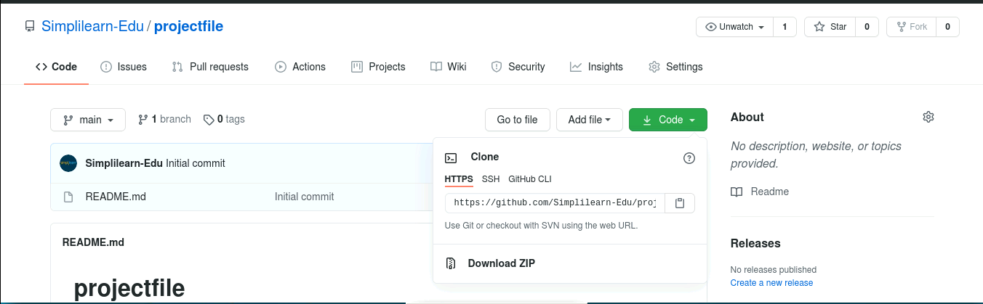

2.4 Open the Terminal tab on your lab, and use the following command to clone the repository:
git clone URL
Note: Replace URL with the copied URL from the repository
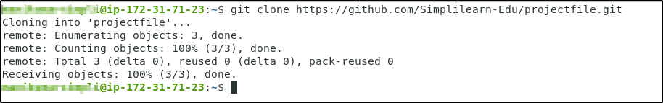

Step 3: List all the branches in your repository
3.1 Open the Terminal in your lab, and navigate to the projectfile folder
cd projectfile
3.2 Use the following command to list all the branches in your repository:
git branch
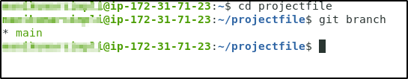

Step 4: Create a new branch
4.1 Run the following command to create a new branch in your repository:
git branch new_branch

Step 5: Verify the creation of the new branch
git branch
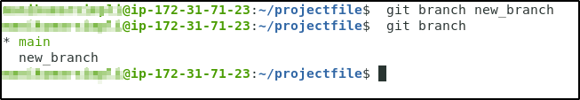
Step 6: Rename an existing branch
6.1 Use the following command to rename the new_branch:
git branch -m new_branch1
6.2 Use the following command to list the branches to verify the new name of the branch:
git branch
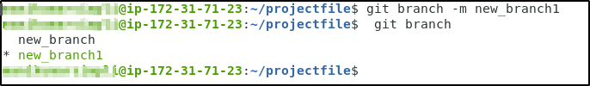

Step 7: Delete the branch
7. 1 Use the following command to delete the newly created branch:
git branch -d new_branch

Step 8: Verify the deletion of the branch
git branch


